Unit 4: Helpful and Harmful Microorganisms
S5L4. Students will relate how microorganisms benefit or harm larger organisms.
a. Identify beneficial microorganisms and explain why they are beneficial.
b. Identify harmful microorganisms and explain why they are harmful.
How can organisms we can't see harm or help us?
How can microorganisms be controlled?

The Littlest Organisms
Let's study the wee ones of the world known as the microbes or the microorganisms. If you spend your life studying them, you would be a microbiologist. These are the smallest of the small and the simplest of the simple. Some of them, like viruses, may not even be alive as we currently define life.
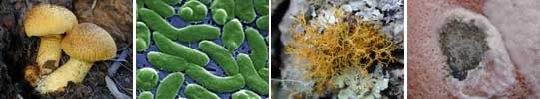

What is a Microbe?
What makes a microbe? We suppose you need a microscope to see them. That's about it. There is a huge variety of creatures in this section. They can work alone or in colonies. They can help you or hurt you. Most important fact is that they make up the largest number of living organisms on the planet. It helps to be that small. It's not millions, billions, or trillions. There are trillions of trillions of trillions of microbes around the Earth. Maybe more.

Calling all Microscopes
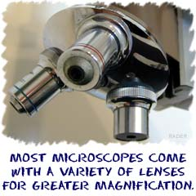
As with all of science, discovery in biology is a huge thing. While microbes like bacteria, fungi, some algae, and protozoa have always existed, scientists did not always know they were there. They may have seen a mushroom here or there, but there were hundreds of thousands of species to be discovered.
It took one invention to change the way we see the world of microbes - the microscope. In 1673, Anton von Leeuwenhoek put a couple of lenses together and was able to see a completely new world. He made the first microscope. It wasn't that impressive, but it started a whole history of exploration. More important to us, scientists were eventually able to discover the cause and cure of many diseases.

Too Many to Count, Too Small to Find
We'll give the big overview on the variety of microorganisms here. There is no simple explanation of a microbe besides the fact that they are small. The list goes on. Just remember that there is a lot of variety going on here.
Task board websites:
Living with Microorganisms:
http://www.bbc.co.uk/bitesize/ks2/science/living_things/microorganisms/read/1/
Virtual Microscope:
http://www.kbears.com/sciences/microscope.html
Become a Special Agent:
http://www.bbc.co.uk/schools/ks2bitesize/science/living_things/microorganisms/play.shtml
• Check out these websites!
    - Microbes in the Cafeteria
    - BBC Bitesize Science - Microorganisms - Interactive activity about helpful & harmful microorganism
    - National Geographic - Creepy Critters - Quiz/game identifying microorganisms that live on the human body
    - NOVA - Disease Detective - Webquest-type activity to identify which microorganisms caused an illness in some campers
    - Microbe Zoo- look up to see where helpful and harmful microbes can be found
    - American Museum of Natural History - Infection, Detection, Protection - Several activities and informational sites about microorganisms and the connection to diseases
    - http://www.kbears.com/sciences/microscope.html

