Subtraction of Mixed Numbers
Subtraction of mixed numbers is a little more complicated than addition of mixed numbers since it is sometimes necessary to borrow.
To subtract two mixed numbers:
- Step 1 Find the LCD of the fractions.
- Step 2 Change the fractions to higher terms with the LCD.
- Step 3 Subtract the fractions, borrowing if possible.
- Step 4 Subtract the whole numbers.
- Step 5 Reduce or simplify the answer if necessary.
When the fraction in the subtrahend is smaller than the fraction in the minuend, borrowing is not necessary.

Example
Subtract

Solution
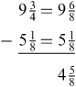

Principles of Borrowing
When the fraction in the subtrahend is larger than the fraction in the minuend, it is necessary to borrow from the whole number.
When borrowing is necessary, take one (1) away from the whole number, change it to a fraction with the same numerator and denominator, and then add it to the fraction .

Examples

Example 1
Borrow 1 from

Solution 1
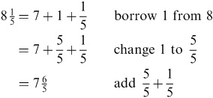

Example 2
Borrow 1 from

Solution 2
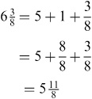
The next examples show how to use borrowing when subtracting mixed numbers.

Example 3
Subtract

Solution 3
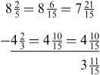

Example 4
Subtract .

Solution 4
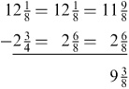

Example 5
Subtract

Solution 5
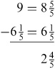

Subtraction of Mixed Numbers Practice Problems

Practice
Subtract:
1.
2.
3.
4.
5.
6.
7.
8.
9.
10.

Answers
1.
2.
3.
4.
5.
6.
7.
8.
9.
10.

