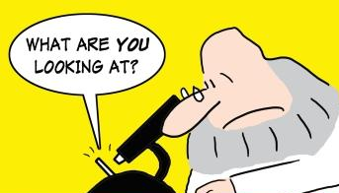

Name _____________________________________________

MICROBE WANTED POSTER

GRADING CHECKLIST
PROJECT CONTENT includes…  - Scientific name of the microbe and any aliases.  - A photo or drawing of the microbe.  - A brief description of microbe and its characteristics.  - An explanation of the harmful effects and Information about whom or what is most commonly affected by the microbe.  - Where the microbe is commonly found.  - Ways to protect against the harmful microbe.  PROJECT RESEARCH includes…  - Accurate information about the microbe.  - Detailed information about the microbe.  - Presentation demonstrates understanding. | / 20
EFFORT and NEATNESS | / 3
CREATIVITY and ORGINALITY  (Extras add to originality of poster.) | / 5
COMPLETED ON TIME. | / 2
TOTAL
Grade Scale:
A 30 – 27 points B 26 – 24 points C 23 – 21 points F Below 21 points

