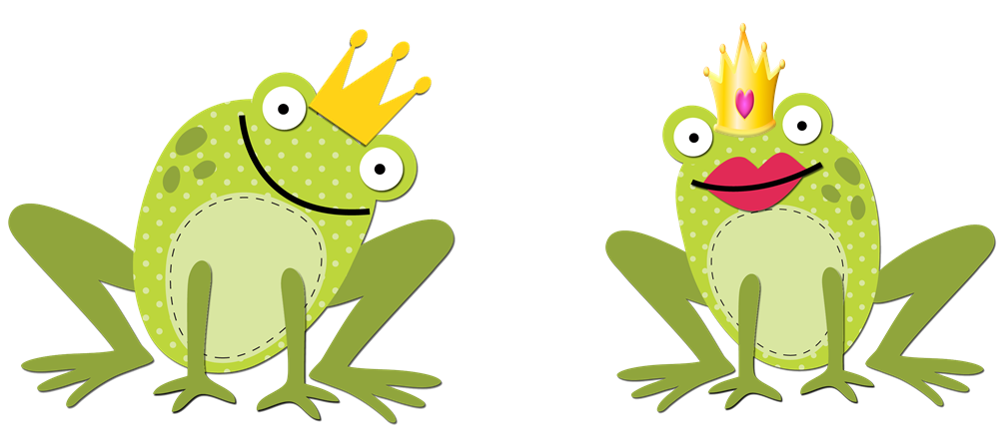

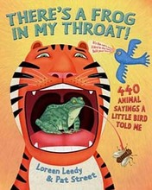

What is Figurative Language?
Figurative language is a word or phrase that does not have its normal everyday, literal meaning. It is used by the writer for the sake of comparison or dramatic effect. Authors use similes, metaphors, hyperbole, and personification to make their stories more interesting.

Simile
A simile uses the words “like” or “as” to compare one object or
idea with another to suggest they are alike.
Example: busy as a bee
Metaphors
The metaphor states a fact or draws a verbal picture by the use of comparison.
A metaphor makes a direct comparison - it says you are something.
Example: You are what you eat.
Personification
A figure of speech in which human characteristics are
given to an animal or an object.
Example: My teddy bear gave me a hug.
Alliteration
The repetition of the same initial letter, sound, or group of sounds in a series
of words. Alliteration includes tongue twisters.
Example: She sells seashells by the seashore.
Onomatopoeia
The use of a word to describe or imitate a natural sound
or the sound made by an object or an action.
Example: snap, crackle, pop
Hyperbole
An exaggeration that is so dramatic that no one would believe the
statement is true. Tall tales are hyperboles.
Example: He was so hungry, he ate that whole
cornfield for lunch, stalks and all.
Idioms
An expression whose meaning is not predictable from
the usual meanings of the actual words.
Example: I have a frog in my throat.

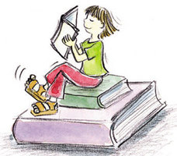  Click on link above. | 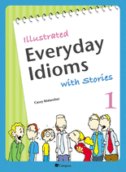  Click on link above.
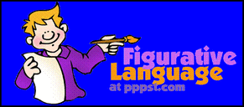  Click on link above. | 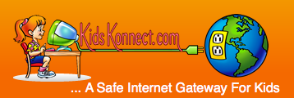  Click on link above.
