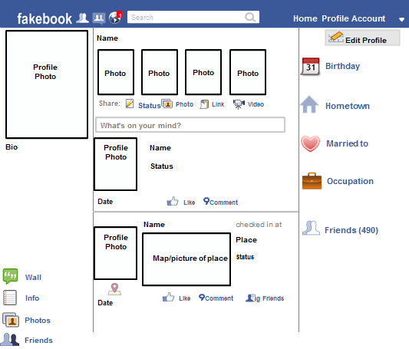
Microorganisms
Directions: Answer the following questions in complete sentences. You should have a minimum of one paragraph (5-8 sentences) written per question.
- How can organisms we can’t see harm us or help us?
- How can microorganisms be controlled?

