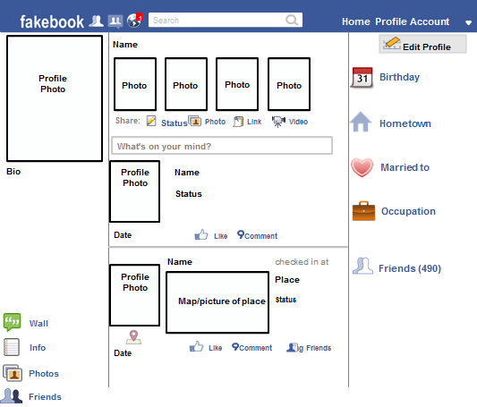

Oct. 21, 2014

Headed to the human throat to help out my friend, Penicillin!

Human throat

[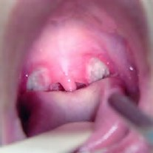](http://www.bing.com/images/search?q=throat&id=091143EB3A53F7FF21F16475A5D3D25C8B608C46&FORM=IQFRBA)

[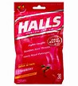](http://www.bing.com/images/search?q=cough+drops&id=F59527FD9864BE45058D7DCF0BB0B278CE73BEB1&FORM=IQFRBA)

Cough Drops

Oct. 21, 2014

1. [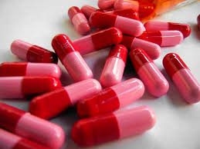](http://www.google.com/url?sa=i&rct=j&q=&esrc=s&frm=1&source=images&cd=&cad=rja&uact=8&ved=0CAcQjRw&url=http%3A%2F%2Fwww.getholistichealth.com%2F2854%2Fpenicillin-doses-report-calls-for-revised-childrens-guidelines%2F&ei=taRGVLSBLcbLgwSKuICwDA&psig=AFQjCNHkF_tP6QqtiGbz5hStzfeCkh0IMQ&ust=1414002182143798)

Status: I am looking for a new throat to infect! You better wash your hands!

1. [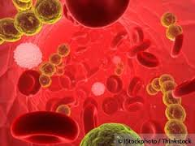](http://www.google.com/url?sa=i&rct=j&q=&esrc=s&frm=1&source=images&cd=&cad=rja&uact=8&ved=0CAcQjRw&url=http%3A%2F%2Farticles.mercola.com%2Fsites%2Farticles%2Farchive%2F2012%2F04%2F16%2Fbacteria-on-gut-flora-causes-ocd.aspx&ei=naJGVIGqMM7pggT8igI&bvm=bv.77880786,d.eXY&psig=AFQjCNFFUbR94BGvNSwckpm1nVuHc7uSgQ&ust=1414001772226769)
2. [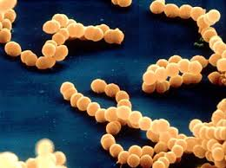](http://www.google.com/url?sa=i&rct=j&q=&esrc=s&frm=1&source=images&cd=&cad=rja&uact=8&ved=0CAcQjRw&url=http%3A%2F%2Ftextbookofbacteriology.net%2Fneisseria.html&ei=naJGVIGqMM7pggT8igI&bvm=bv.77880786,d.eXY&psig=AFQjCNFFUbR94BGvNSwckpm1nVuHc7uSgQ&ust=1414001772226769)
3. [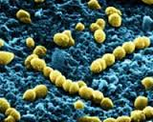](http://www.google.com/url?sa=i&rct=j&q=&esrc=s&frm=1&source=images&cd=&cad=rja&uact=8&ved=0CAcQjRw&url=http%3A%2F%2Fwww.spacedaily.com%2Freports%2FShuttle_Brings_Space_Grown_Strep_Bacteria_Back_For_Study_999.html&ei=tqNGVPnvLYbxgwTu7IKwDQ&bvm=bv.77880786,d.eXY&psig=AFQjCNFFUbR94BGvNSwckpm1nVuHc7uSgQ&ust=1414001772226769)
4. [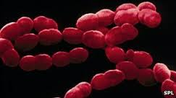](http://www.google.com/url?sa=i&rct=j&q=&esrc=s&frm=1&source=images&cd=&cad=rja&uact=8&ved=0CAcQjRw&url=http%3A%2F%2Fwww.bbc.co.uk%2Fnews%2Fhealth-16756380&ei=naJGVIGqMM7pggT8igI&bvm=bv.77880786,d.eXY&psig=AFQjCNFFUbR94BGvNSwckpm1nVuHc7uSgQ&ust=1414001772226769)
5. [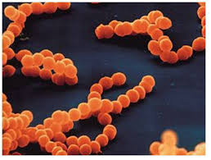](http://www.google.com/url?sa=i&rct=j&q=&esrc=s&frm=1&source=images&cd=&cad=rja&uact=8&ved=0CAcQjRw&url=http%3A%2F%2Fwww.geocities.ws%2Frespiratorydisease%2Fsite%25206%2Fstrep%2520throat.html&ei=naJGVIGqMM7pggT8igI&bvm=bv.77880786,d.eXY&psig=AFQjCNFFUbR94BGvNSwckpm1nVuHc7uSgQ&ust=1414001772226769)

Watch out Strep Throat! I am coming to get you! You will be evicted from all throats by the end of the day!

Penicillin

* E. Coli
* Tetanus
* Rabies
* Pneumonia
* Meningitis
* Botulism

Infecting the throats and nostrils of living organisms causing them to get sick

Mr. Throat

Holland

October 24, 1674

I am a bacterial infection. I live in the throat and the tonsils. When I am present the throat gets irritated and inflamed, causing a sudden, severe sore throat. I am caused by streptococcal (strep) bacteria. I come in many different forms and there are many types of me**.** Some cause more serious illness than others.

Mrs. Strep Throat