5th Grade Figurative Language
Alliteration
Alliteration is the repetition of a consonant sound at the beginning of words.
Examples:
The sweet smell of success
It’s now or never

Simile 
A comparison between two unlike things that have something in common is called a simile. A simile always uses the words like or as to make a comparison.
Examples:
Paul Bunyan was as strong as an ox.
The forest was as quiet as a falling leaf.

Metaphor 
A metaphor is a figure of speech comparing two unlike things that have something in common. The comparison is made without the use of like or as.
Examples:
My voice was a cannon breaking the silence.
Her hair was silk.
Personification 
Personification is giving human traits (qualities, feelings, action, or characteristics) to non-living objects (things, colors, qualities, or ideas).
Examples:
The sun smiled at me as it popped up.
The rain kissed my cheeks as it fell.
5th Grade Figurative Language
Hyperbole
Hyperbole is exaggeration. It puts a picture into the "reader" mind. Hyperbole is frequently used in humorous writing. Examples:
I nearly died laughing.
I tried a thousand times.

Imagery
To make an imaginary world seem real, an author often makes use of words and phrases that appeal to the senses. These words and phrases, called images help a reader mentally experience what the characters in the literary selection are actually experiencing.
 Sight-orange glare, green meadows, wilted and dry willows
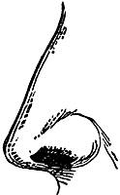 Smell-dusty odor of the dry Earth
Taste-a tall frosted glass of lemonade, the bland taste of starchy bananas
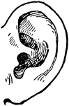Sound-crackling underbrush
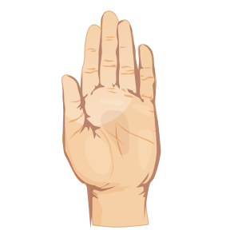Touch-hot July sun, damp jeans, tepid water

Onomatopoeia
The use of words to imitate sounds is called onomatopoeia.
Examples:
Bang, pop, hiss, and sizzle
5th Grade Figurative Language
Idioms
An idiom or idiomatic expression refers to a construction or expression in one language that cannot be matched or directly translated word-for-word in another language. It is not literal.
Examples:
She is green with envy.
It’s a piece of cake.

Puns 
A Pun is the humorous use of a word or words, which are formed or sounded alike but have different meanings, in such a way as to play on two or more of the possible applications; a play on words
Examples:
I used to be a transplant surgeon, but my heart just wasn't in it.
What did the toy store sign say? Don't feed the animals. They are already stuffed.

Palindromes
Palindromes are words or phrases which read the same backwards as forwards.
Examples:
Racecar
go dog
Was it a car or a cat I saw? 

5th Grade Story Elements
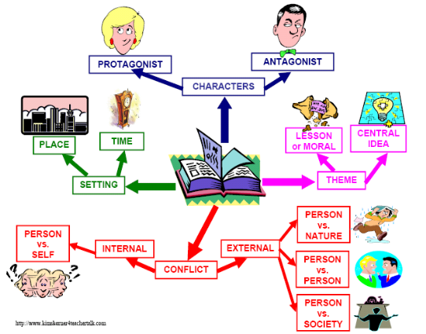

Setting 
The setting of a story is the place where the story happens and the time when it happens. The setting answers the questions of where and when. The setting doesn’t have to be a real time and place. It can be imaginary, like the island, Never land, in the story of Peter Pan.

Character 
Every person or animal who takes part in the action of a story, poem or play is called a character. The most important characters are called major characters. Everyone else is a minor character. Character Traits A quality that a character exhibits is called a character trait. This trait can be indicated by the character's statements, actions, or thoughts.
5th Grade Story Elements

Conflict in Plot 
The plot is what happens, concretely, as though it were placed on a history time line. Conflict is essential to plot. Without conflict there is no plot. It is the opposition of forces which ties one incident to another and makes the plot move.

Theme 
Theme is the life lesson, meaning, moral, or message about life or human nature that is communicating by a literary work. Themes are not explicit (clearly stated). Themes are bigger than the story.

Dialogue 
Dialogue is a discussion or conversation between two or more characters.

5th Grade Dramatic Literature


Cast of Characters
A list of the characters in the play with a short description of each.
Scenes
A subdivision of an act in a dramatic presentation in which the setting is fixed and the time continuous.
Acts
A large division of a full-length play, separated from the other act or acts by an intermission
Stage Directions
The writer's instructions for performing the play. They tell actors how to move or deliver lines. They also describe the stage set, costumes, and props. In the written version of a play, stage directions are often printed in italics.
Poetry
Stanza
Two or more lines of poetry that together form one of the divisions of a poem. The stanzas of a poem are usually of the same length and follow the same pattern of meter and rhyme
Rhyme
Rhyme is the similarity in sound of the ends of words: the last stressed syllable and the following unstressed syllables (if any). Rhyme is usually a structuring device in verse.
Rhyme Scheme
When rhyming verses are arranged into stanzas, we can identify the rhyme scheme by assigning letters each rhyme, beginning with a and proceeding through the alphabet. Example: aa bb
Refrain
A line or group of lines that is repeated throughout a poem, usually after every stanza
5th Grade Organizational Structures

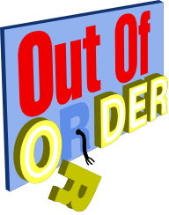Chronological Order
Chronological order presents ideas according to the time in which they occurred. This type of organization is especially effective if you are describing a process, relaying a series of actions, or telling a story. For instance, to convey the plot of a novel or the procedures of an experiment, you would tell readers what happened first, second, etc.

Logical Order 
Logical order is the most common method of organizing your written thoughts in an essays. When you use this method you group related ideas together and discuss each group, one after the other. Therefore remember to group your ideas into common groups and this will help your writing coherence

Cause and Effect
Cause is something that makes something else happen. Out of two events, it is the event that happens first. To determine the cause, ask the question "Why Did it Happen?" An effect is what happens as a result of the cause. Of two related events, it’s the one that happens second or last. To determine the effect, ask the question "What Happened?"

5th Grade Vocabulary Acquisition

Root Word
Root word is a word that has nothing added at the beginning or the end. It stands on its own as a word, it has a meaning. New words can be made from root words by adding beginnings (prefixes) and endings (suffixes).

Prefix
A prefix is a group of letters which you can add to the beginning of a root word* to change the meaning of the word. e.g. mis + fortune = misfortune
Prefix | Meaning
mis | means 'wrong' or 'badly'
sub | means under
pre | means 'before in time', 'in front of' or 'superior'
un | means not (there are also several other prefixes which mean not)

Suffix
A suffix is a word ending. It is a group of letters you can add to the end of a root word* e.g. walking, helpful
Suffix | Example
ed | walk + ed = walked
ing | say + ing = saying
er | tall + er = taller
tion | educate + tion = education
sion | divide + sion = division
fully | hope + fully = hopefully
est | large + est = largest

5th Grade Vocabulary Acquisition

Antonym 
a word opposite in meaning to another. Fast is an antonym of slow.

Synonym 
a word having the same or nearly the same meaning as another in the language, as joyful, elated, glad.

Homophone 
a word pronounced the same as another but differing in meaning, whether spelled the same way or not, as heir and air.

5th Grade Conventions
Type of Sentence | Use | Punctuation Mark
Declarative | Makes a statement | Period  ( . )
Interrogative | Asks a question | Question Mark  ( ? )
Imperative | Gives a command or  makes a request | Period  ( . )
Exclamatory | Expresses strong feeling | Exclamation Mark  ( ! )

5th Grade Conventions Fragments  A sentence fragment is an incomplete sentence. Some fragments are incomplete because they lack either a subject or a verb, or both. Dependent clauses—they have a subject and a verb, so they look like complete sentences, but they don't express a complete thought. Examples: Because his car was in the shop After the rain stops When you finally take the test
Run-ons 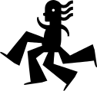 You are making a run-on when you put two complete sentences (a subject and its predicate and another subject and its predicate) together in one sentence without separating them properly. Example: My favorite Mediterranean spread is hummus it is very garlicky.
Modifier A modifier can be an adjective, an adverb, or a phrase or clause acting as an adjective or adverb In every case, the basic principle is the same: the modifier adds information to another element in the sentence.
Verb Tenses 
An action which indicated a time of occurrence
Past: Already happened
Present: Is currently happening
Future: Will happen in the future
5th Grade Conventions

SIMPLE SENTENCE A simple sentence, also called an independent clause, contains a subject and a verb, and it expresses a complete thought. Examples: Some students like to study in the mornings. Juan and Arturo play football every afternoon. Alicia goes to the library and studies every day.
COMPOUND SENTENCE A compound sentence contains two independent clauses joined by a coordinator. The coordinators are as follows: for, and, nor, but, or, yet, so. (Helpful hint: The first letter of each of the coordinators spells FANBOYS.) Examples: I tried to speak Spanish, and my friend tried to speak English. Alejandro played football, so Maria went shopping. Alejandro played football, for Maria went shopping.
COMPLEX SENTENCE A complex sentence has an independent clause joined by one or more dependent clauses. A complex sentence always has a subordinator such as because, since, after, although, or when or a relative pronoun such as that, who, or which. Examples: When he handed in his homework, he forgot to give the teacher the last page.
The students are studying because they have a test tomorrow.
After they finished studying, they went tot the movies.
Compound Complex A compound-complex sentence is made from two independent clauses and one or more dependent clauses. Example: Although I like to go camping, I haven't had the time to go lately, and I haven't found anyone to go with.

5th Grade Conventions
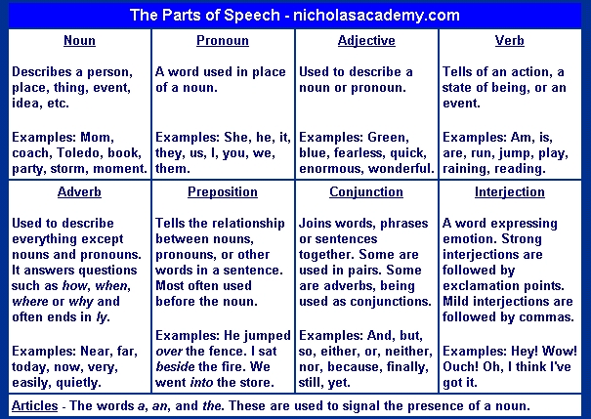
5th Grade Conventions

Language of the CRCT

5th Grade Text Features
Headings- Usually found at the top of the page or paragraph; usually printed in a larger or colored font; describes the topic or paragraph in a one- or two-word phrase
Captions- One to two sentences that describe an illustration or photograph; usually appears underneath the picture, but sometimes above or to the side of it
Labels-Often added to photographs or illustrations to provide more information to the reader
Diagrams, charts, graphs, tables Used to show written or additional information in a different and simple way; provides visual appeal to a two-page spread
Photographs and illustrations
Adds visual appeal to the page; provides support for the written text
5th Grade Reference Sources
Dictionary 
A dictionary provides information about the meaning, pronunciation, and spelling of words. Guide words appear at the top of each dictionary page. The word in the left corner is the first entry on the page and the word in the right corner is the last entry on the page. Guide words enable you to locate a word quickly.
Thesaurus
A thesaurus contains synonyms for commonly used words. A thesaurus can help you precisely express your ideas when writing.

Encyclopedia 
An encyclopedia contains articles on a variety of subjects. The articles are written by experts on each of the subjects. In addition to articles, encyclopedias may include illustrations and diagrams, definitions of some words, and references to additional information.
Almanac
An almanac is an annual single-volume reference source that contains useful facts about a wide range of topics. You can learn about countries of the world, government, historical events, and many other topics. Because almanacs are revised each year, the information is current.
5th Grade Reference Sources

Atlas 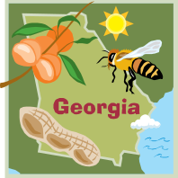
An atlas is a collection of maps. The most common atlas contains maps that show the political and physical features of countries throughout the world. A political map shows government boundaries. A physical map shows the features of the earth's surface such as mountains, deserts, and bodies of water.
Magazine 
A magazine is a publication issued at regular intervals, usually weekly or monthly, containing articles, stories, photographs, advertisements, and other features.

Newspaper 
Newspapers are a publication containing news and comment on current events, together with features and advertisements, that usually appears daily or weekly and is printed on large sheets of paper that are folded

5th Grade Print Features

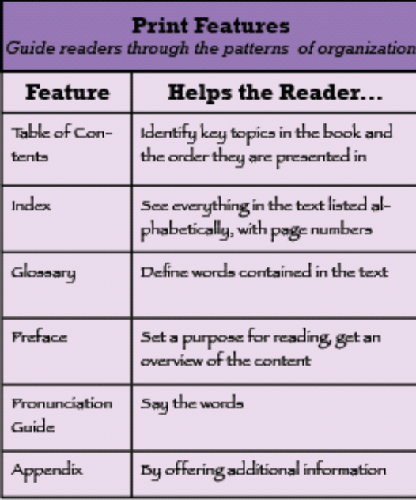
5th Grade Computer Technology Vocabulary
Software is the programs that run on a computer.

Memory is temporary storage space on chips in your computer.

Disk Drive is a part of the computer that operates the disks that store information.

Hard Drive is the hard disk is a round, metal platter in the hard drive of the computer; it stores large amounts of information.

